**Design**

All fonts on this website are by default Segoe UI with alternatives being from first to last Tahoma, Verdana and sans-serif.

Tabs on each page should display the website logo and what page you’re on.

Low Fidelity

Login Page

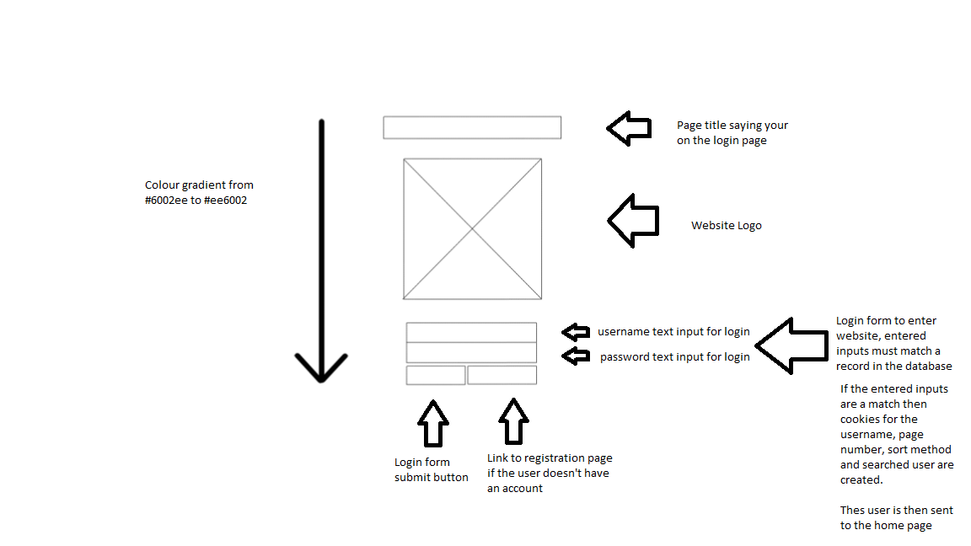

JS: openNav function called when page loads

Registration Page

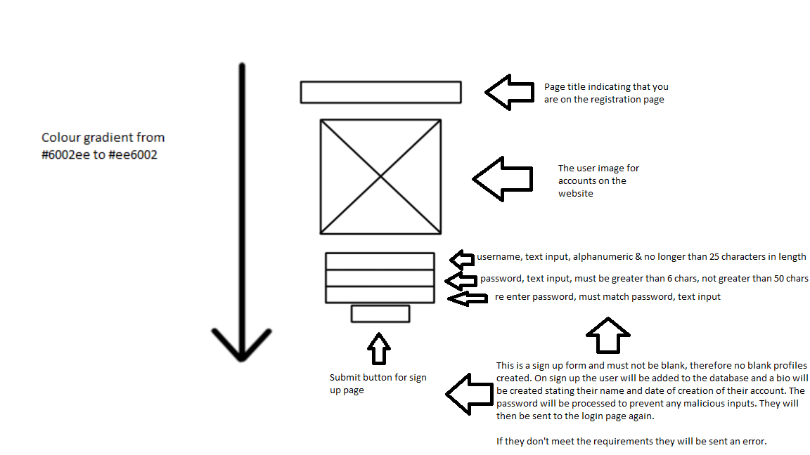

JS: openNav function called on page load

Home Page

Case 1:

nothing expanded 50 posts

The search icon is search.png, JS: feed function called on page load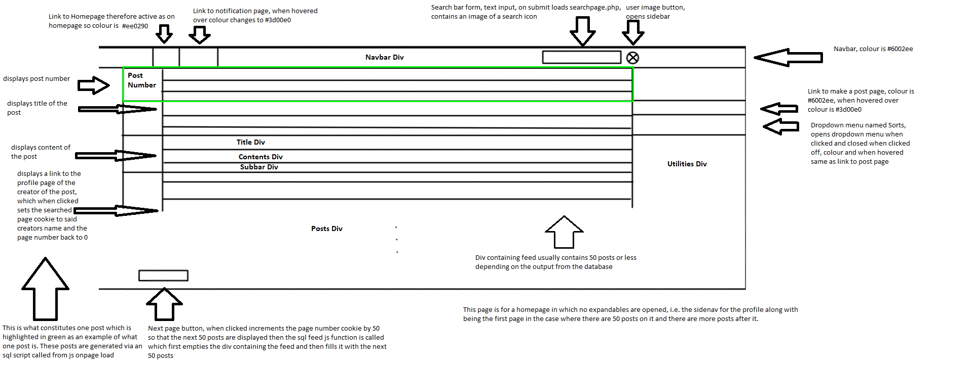

Case 2:

Dropdown expanded, on page that is not the first or last

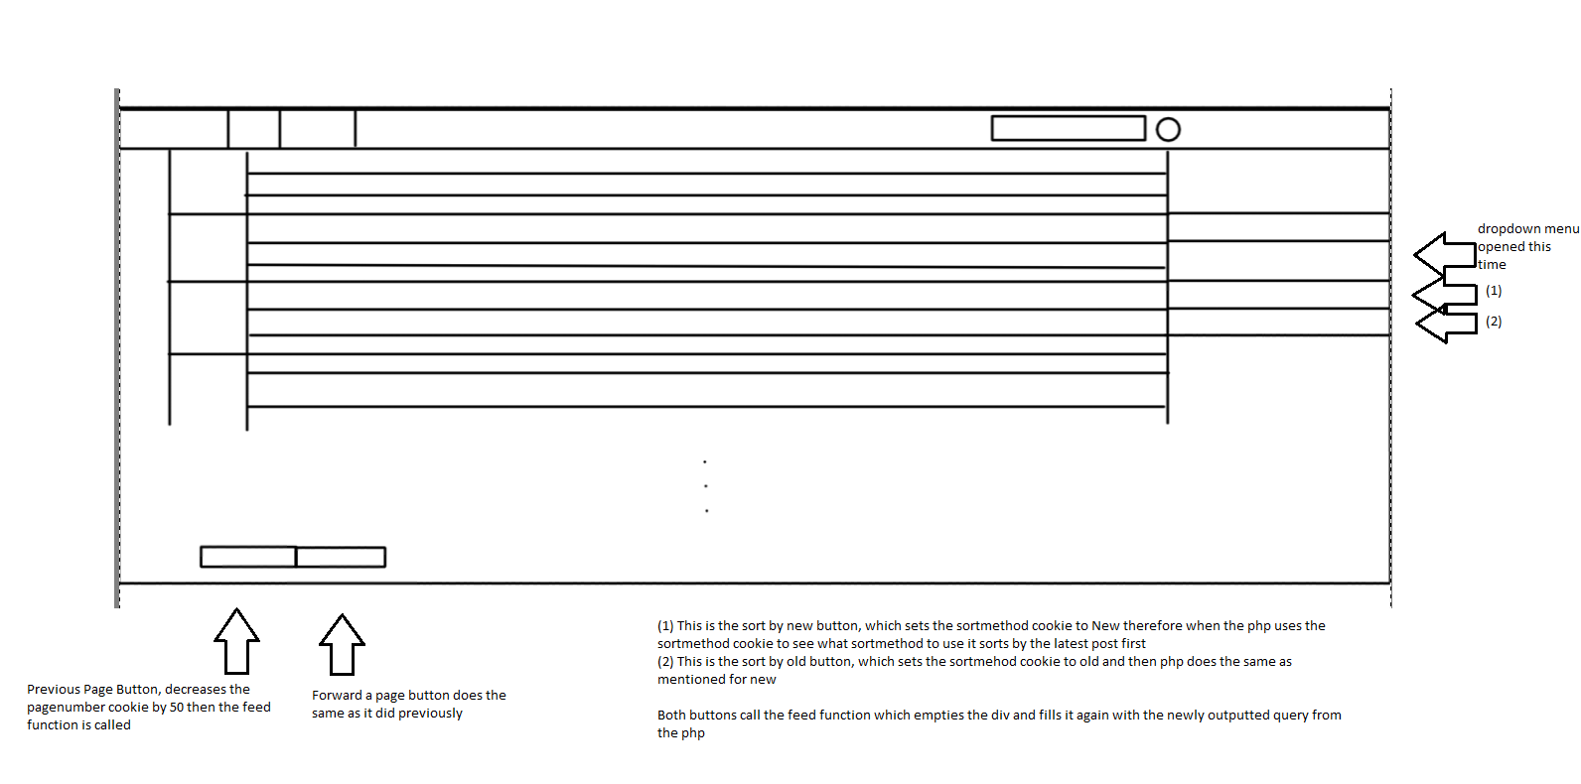

Case 3:

Sidenav expanded, done via js when user image button clicked, last page

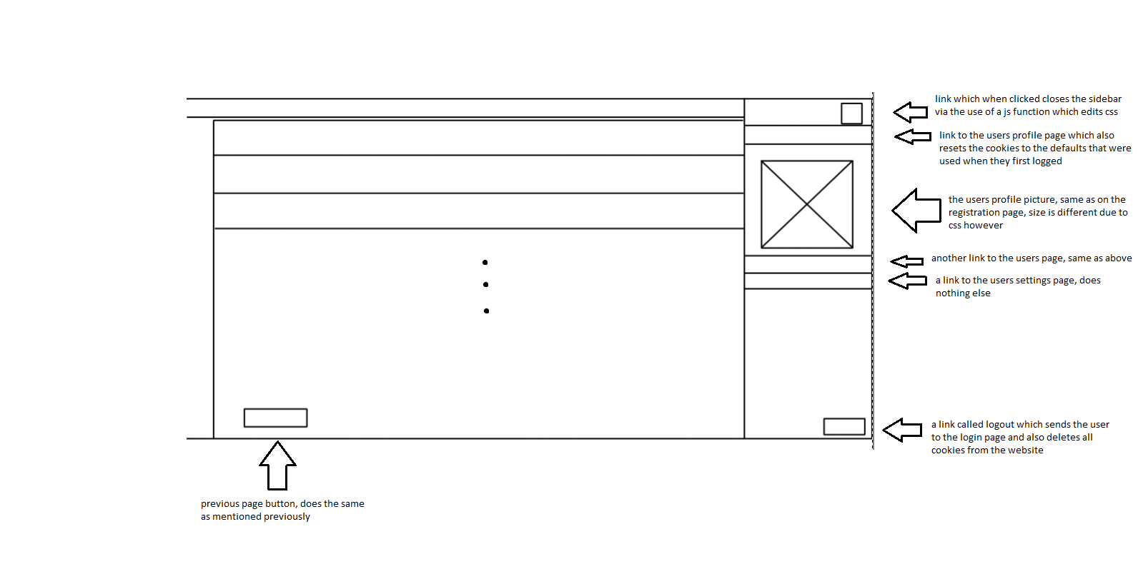

There is a 4th case where the first page has less than 50 posts but that simply means there’s no forward/back button, everything

else on the page is the same and does the same thing. I’m also dubbing the sidebar containing make post and sorts the utilities and the top bar containing home and notifications etc the nav bar. I won’t be doing the expanded sorts or user profile button as they do the same thing on each page that they exists on.

Notifications Page

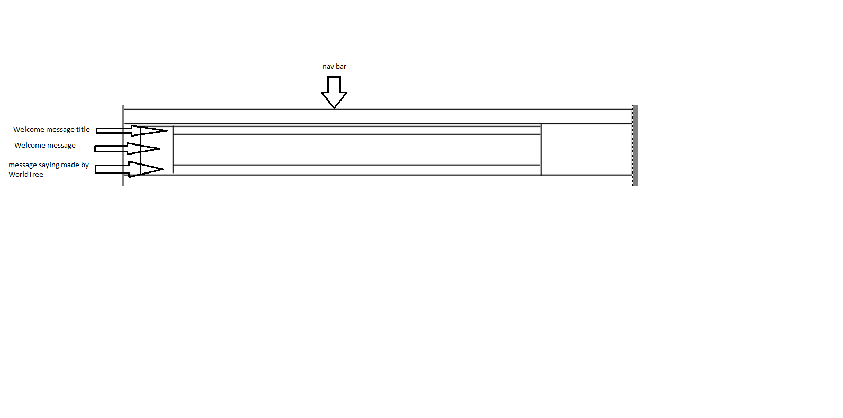

Forgot to mention that on notifications page the notifications link in the nav bar is active

Profile Page

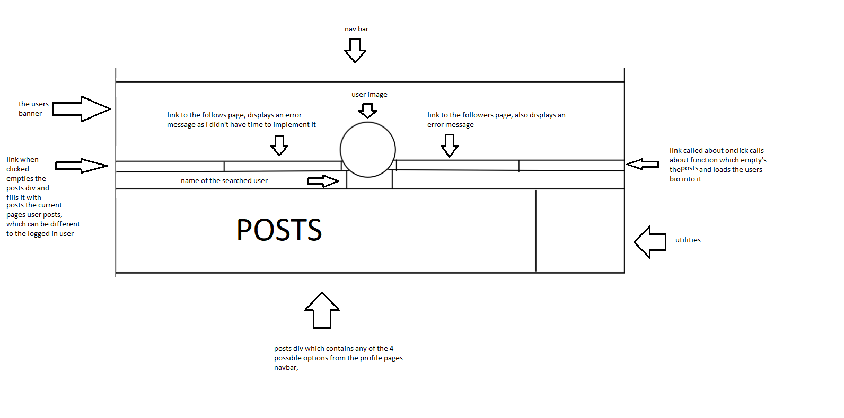

JS: profile and feed functions called on page load

Search Page

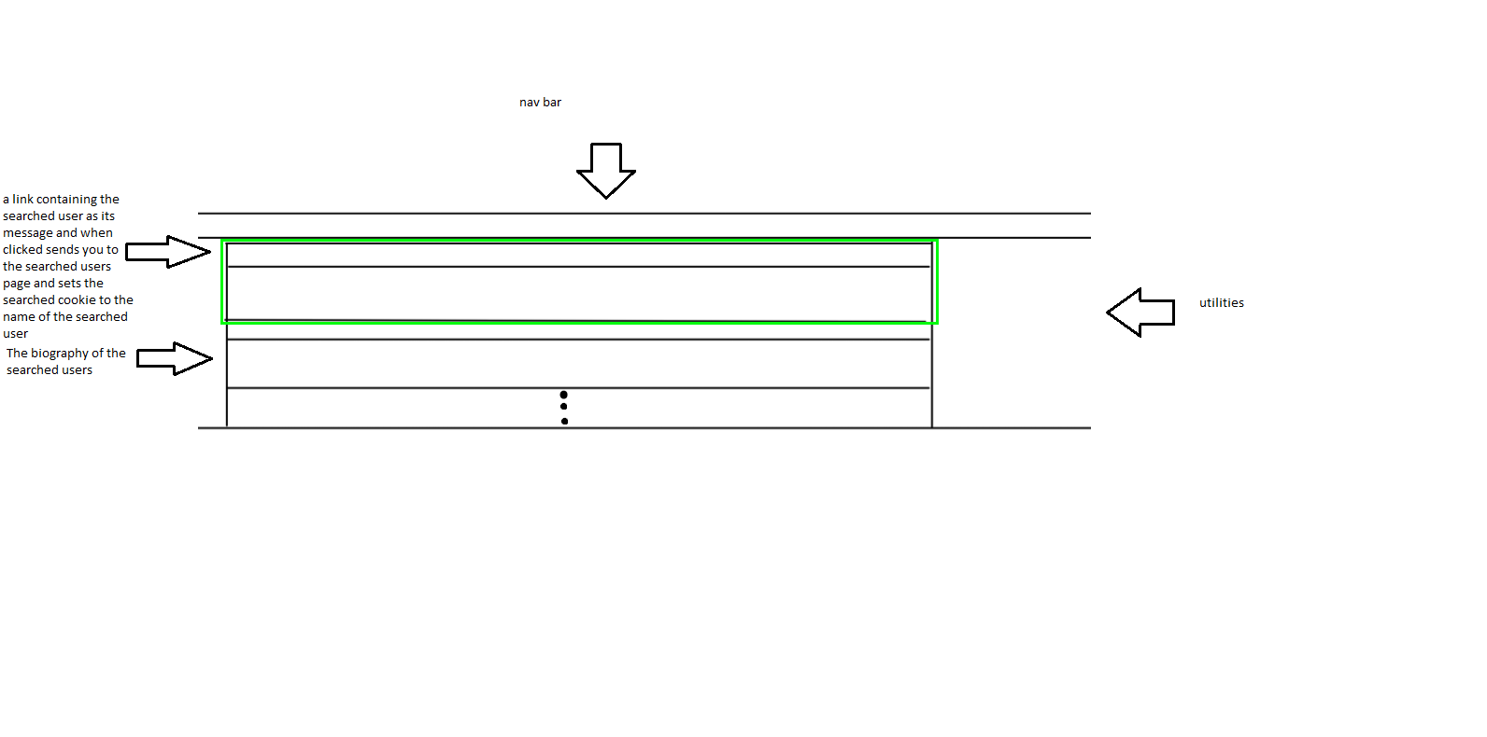

the green is one searched result

JS: search function called on page load

Settings Page

Case 1:

Preferences Page

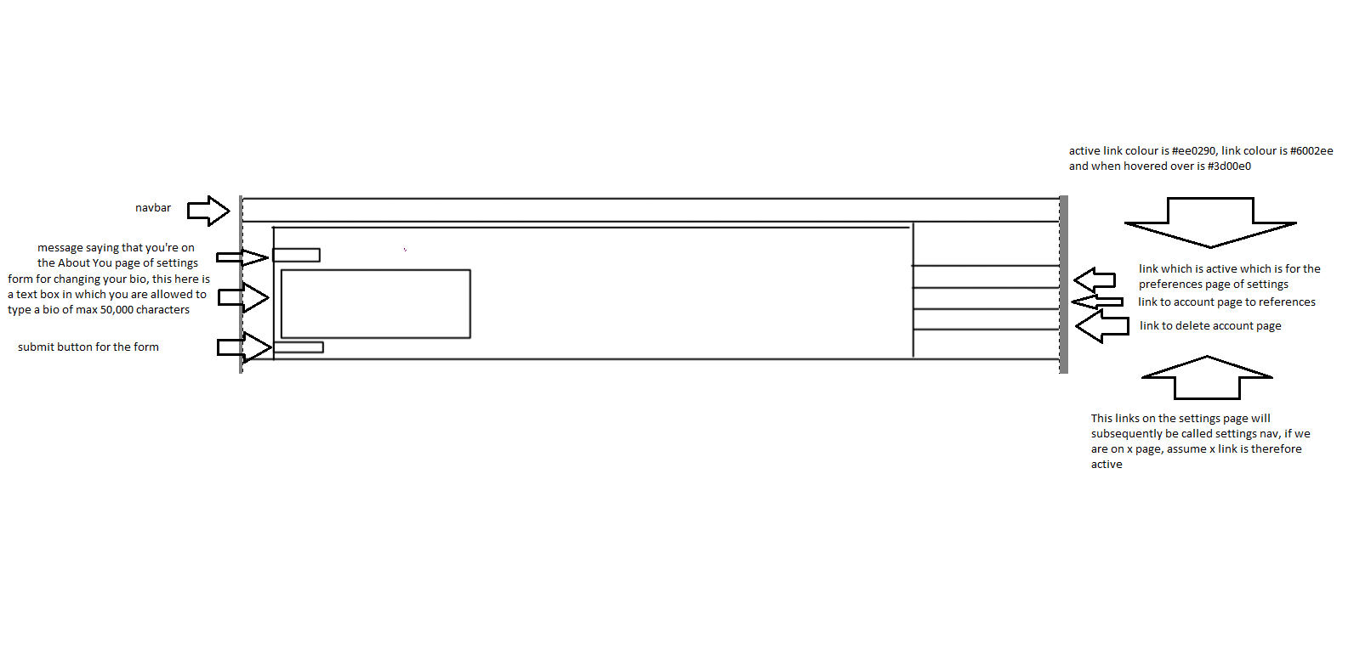

Case 2:

Account Page

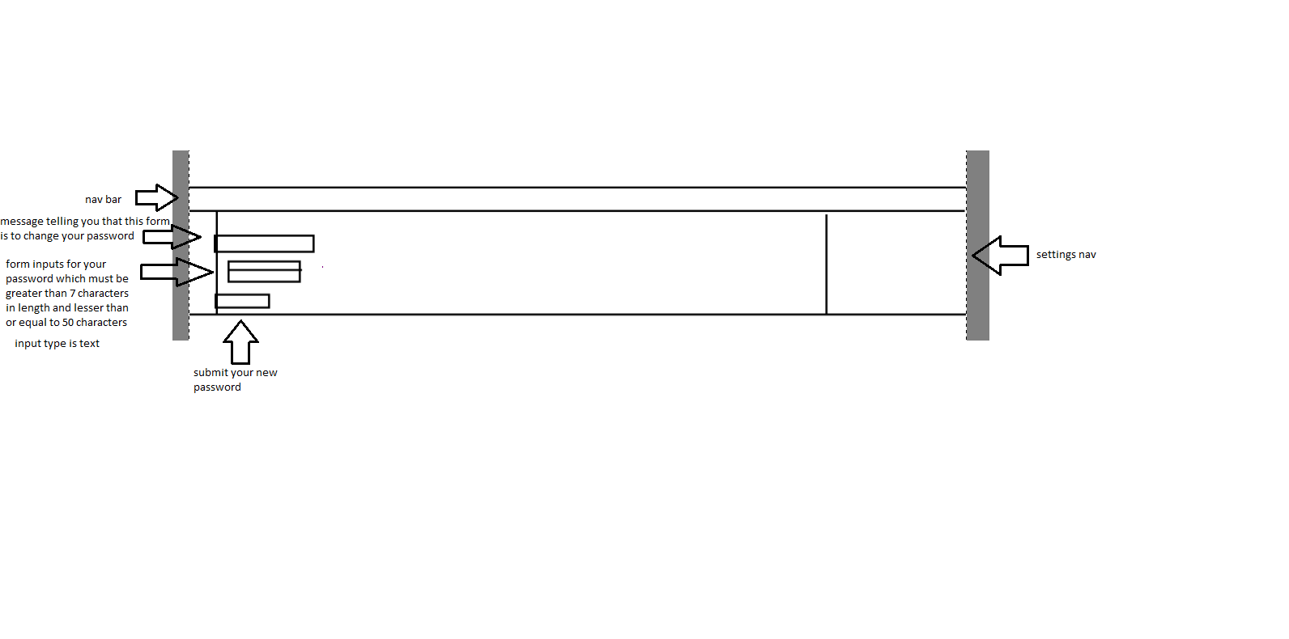

Case 3:

Delete Account Page

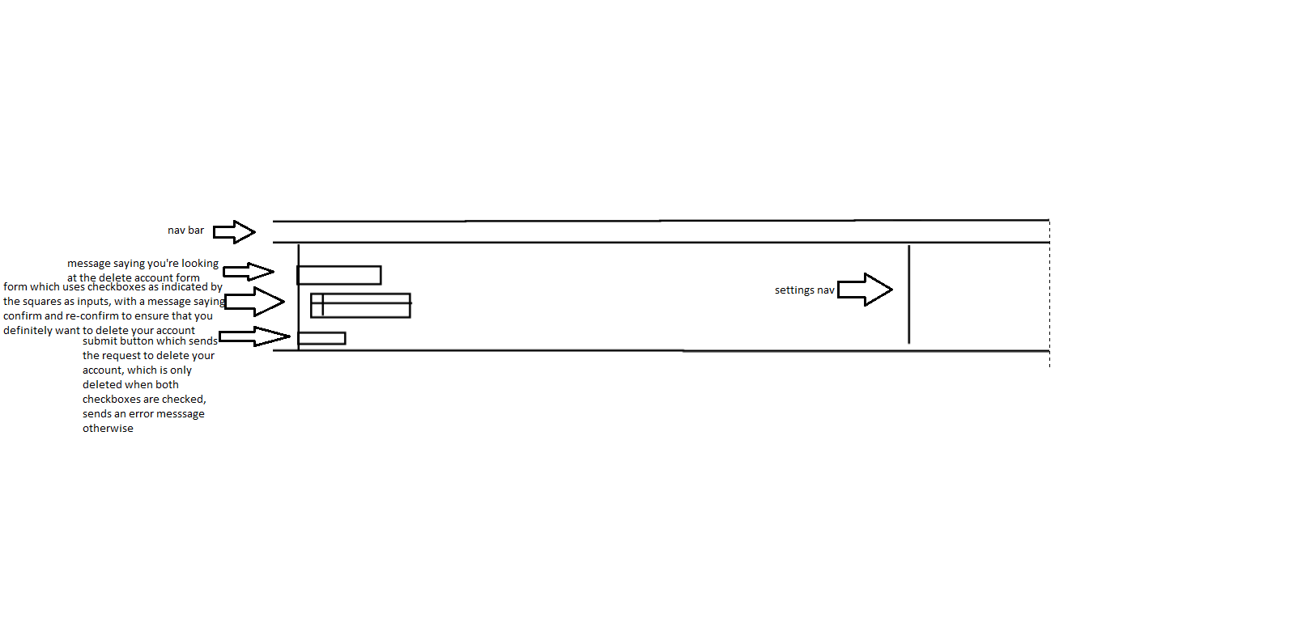

Make a Post Page - Text

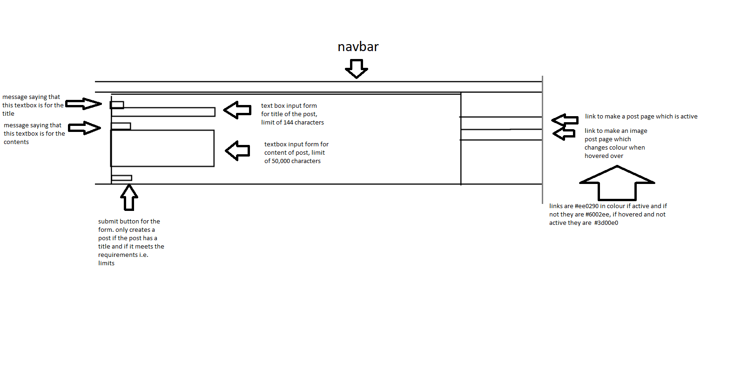

The sidenav containing links I will call createpost nav

Make a Post Page - Image

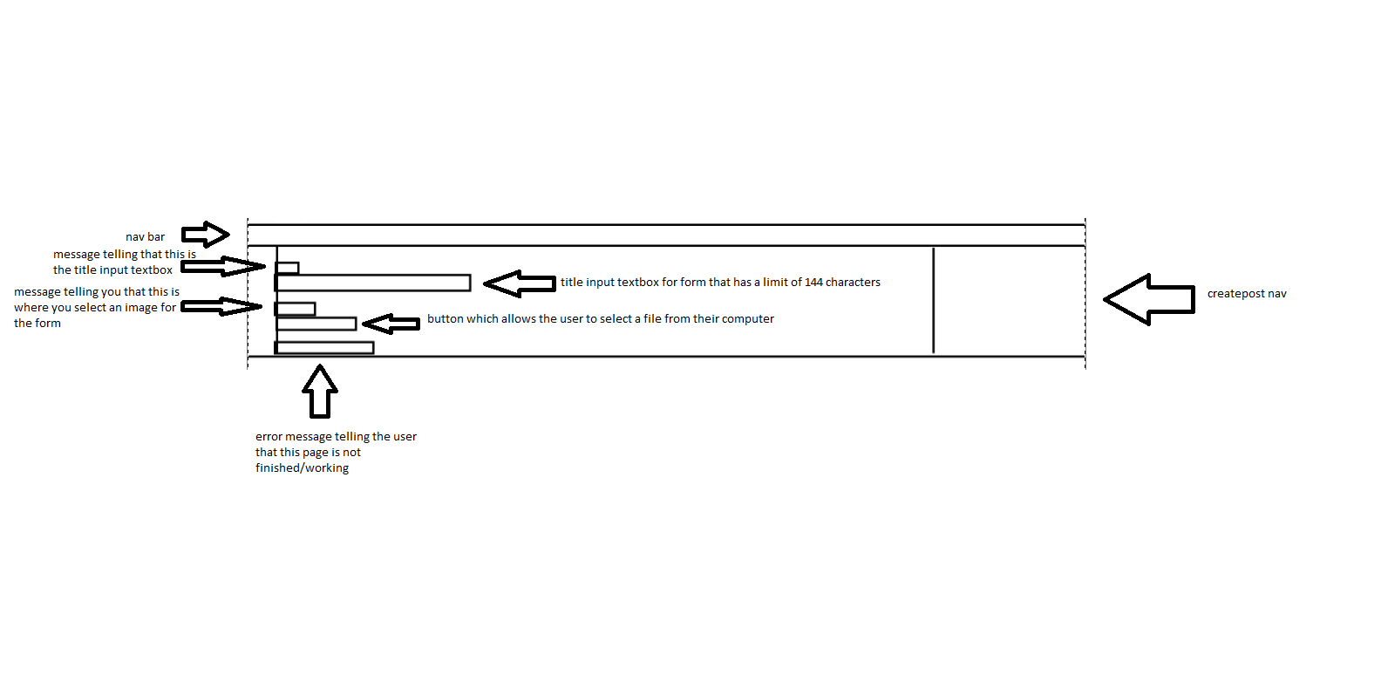

High Fidelity

Do note that all the following screenshots are not of the final program as none of the links work and they are all html files with no php backing them. They have minimal javascript so that things like the dropdown or the sidebar can be opened. In addition to this, images have been cropped in some occurrences so that unnecessary excess is gone. Things labelled as default will have their default css other than their font which is the same as everything else

Login Page

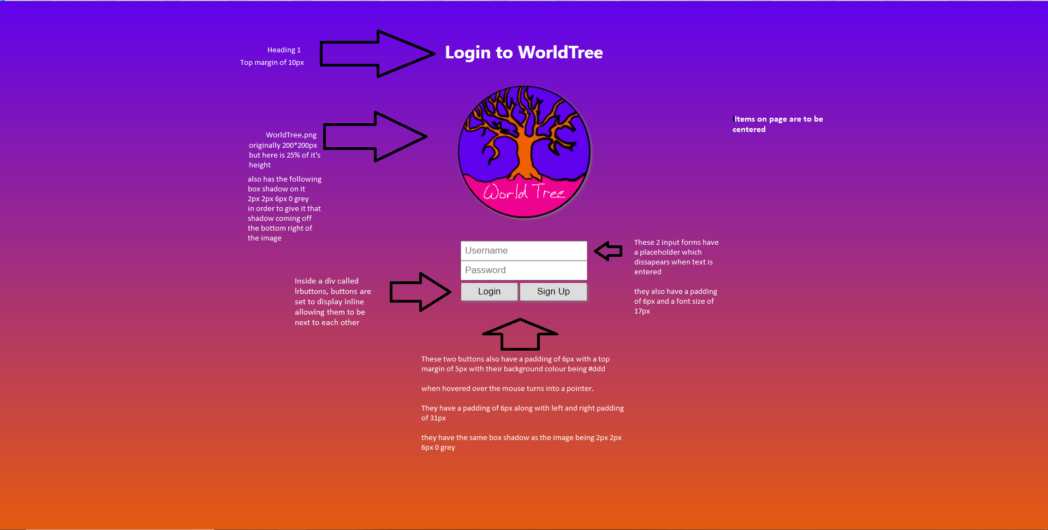

The text, inputs etc are

centered on the page.

The buttons are centered

due to the div they are in

being centered, they are

next to each other

because the they are

inline.

Registration Page

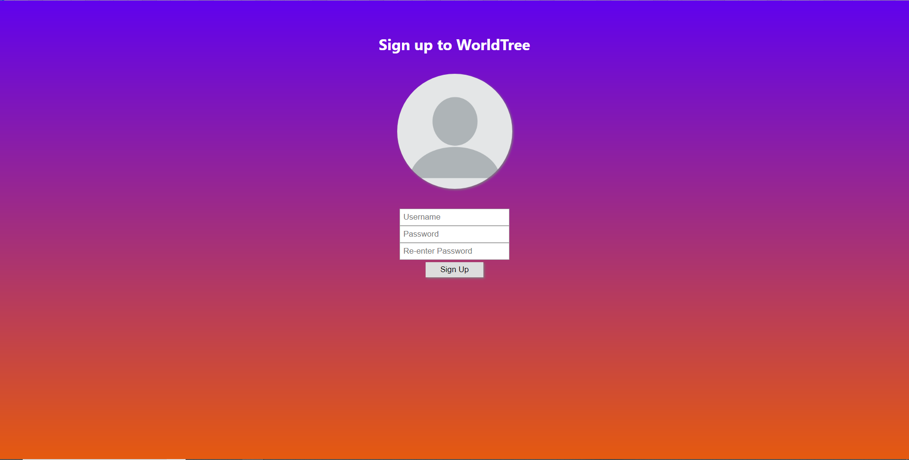

The high fidelity for the registration page contains the same properties as those of the login page so I will not be commenting on them. Please refer to the descriptions given on the previous page in order to see what the parameters for the high fidelity for the login page would be.

I forgot to mention but the images on both pages have a border radius of 50% to make the images a circle.

Image on this page is avatar.png

Home Page

Case 1:

nothing expanded 50 posts

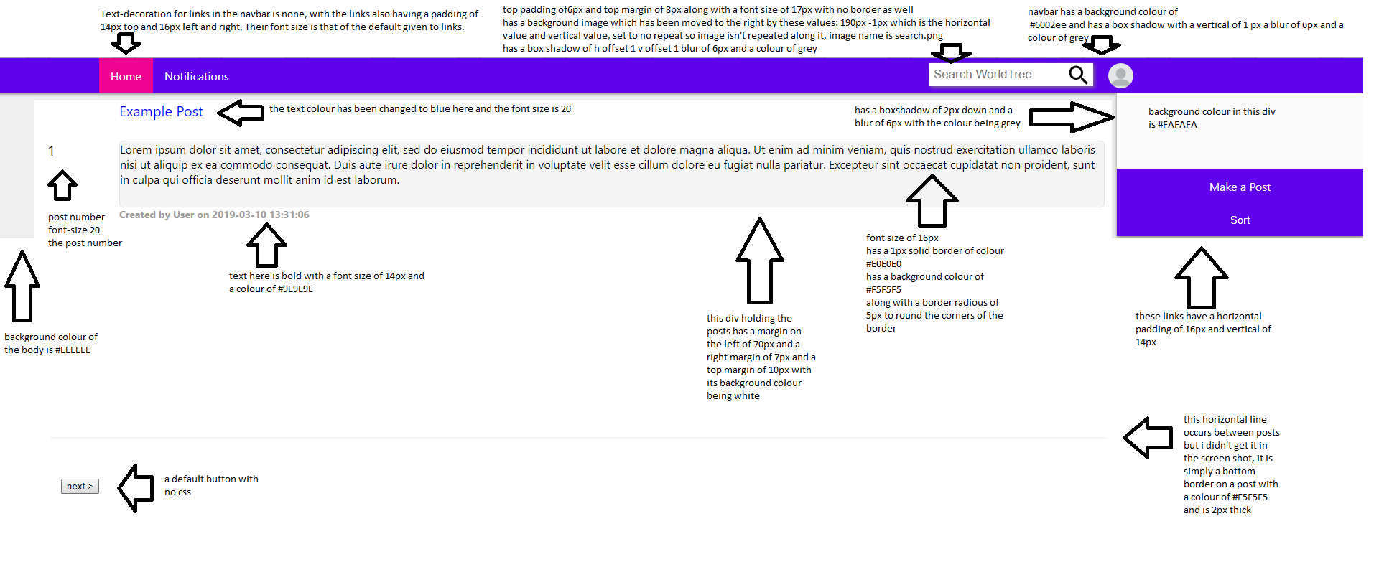

The text in the sidebar make post etc buttons are centered. When these buttons are hovered over they change colour from #6002ee to #3d00e0. They have a default font size.

Case 2:

Dropdown expanded, on page that is not the first or last

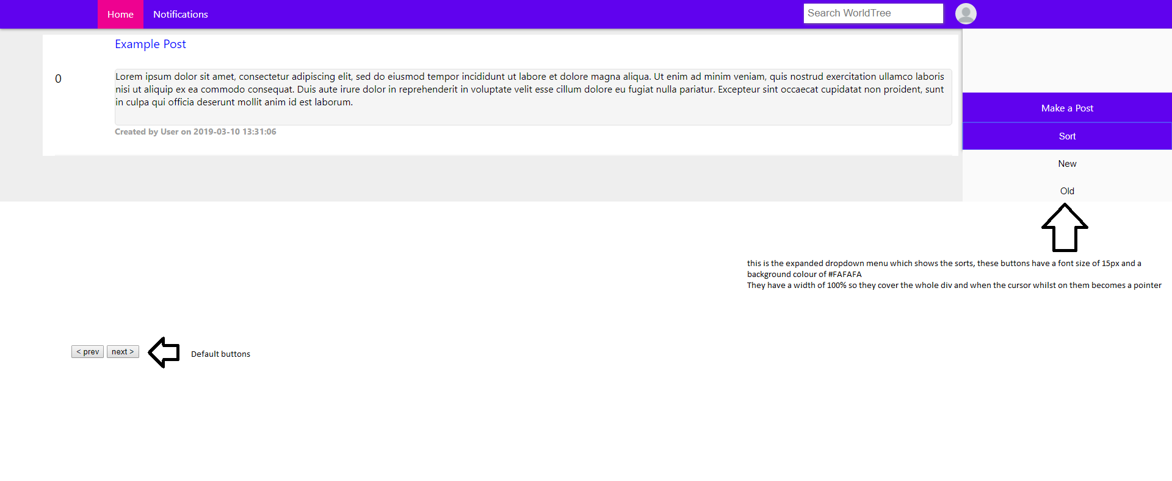

Again the text in the dropdown is centered, when hovered over its text colour goes to #E0E0E0

Case 3:

Sidenav expanded, done via js when user image button clicked, last page

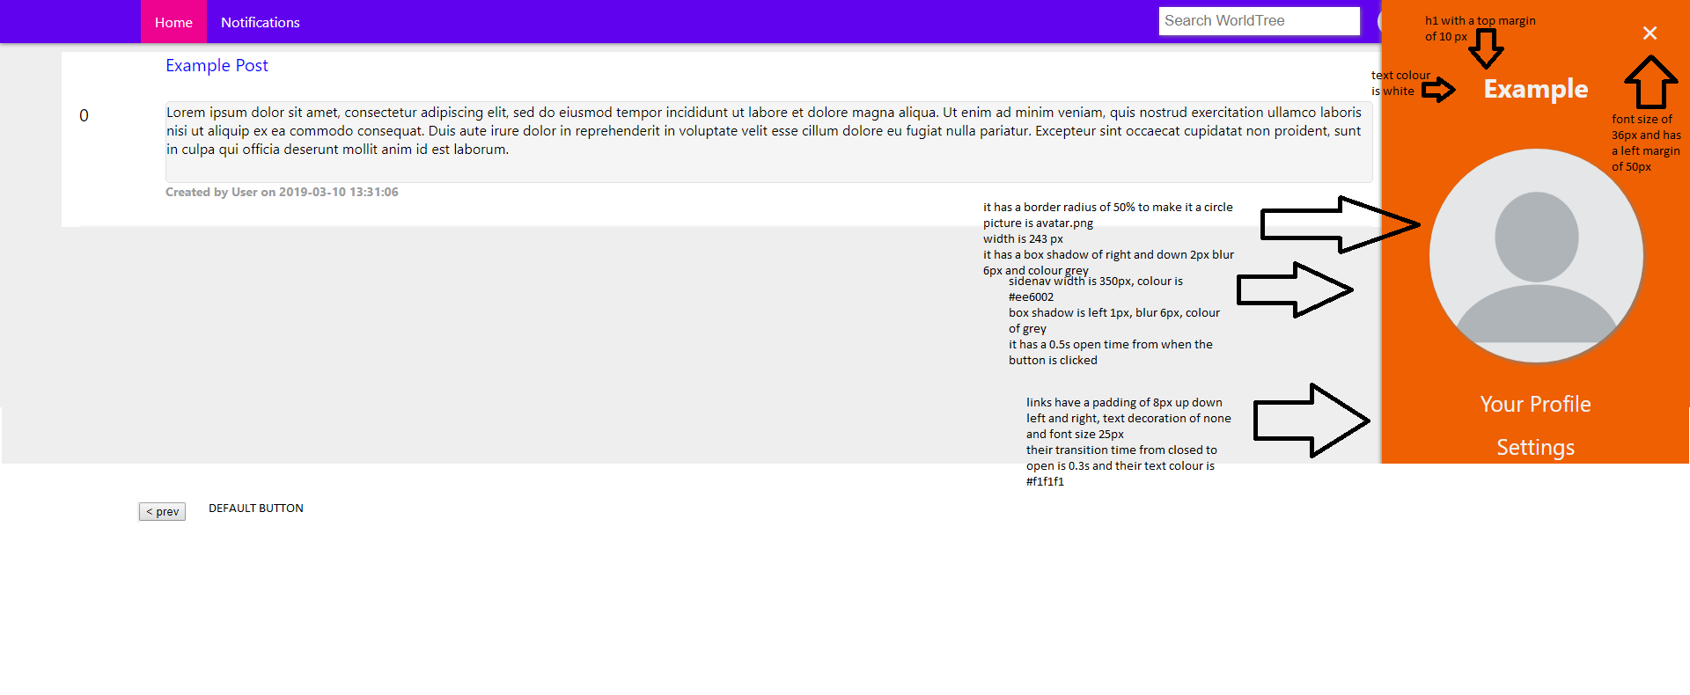

Again some of the properties are shared with previous pages. The image and text, buttons etc in the sidebar are centered

Notifications Page

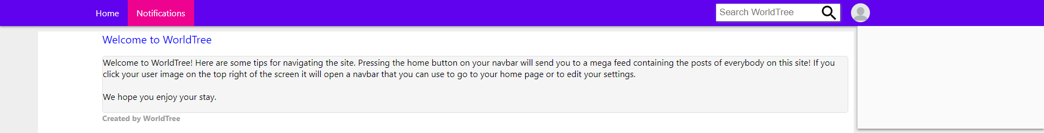

All properties on this page are the same as those said on the home page, differences being that there are no sidebar buttons along and that the WorldTree text in the subbar is not a link

Profile Page

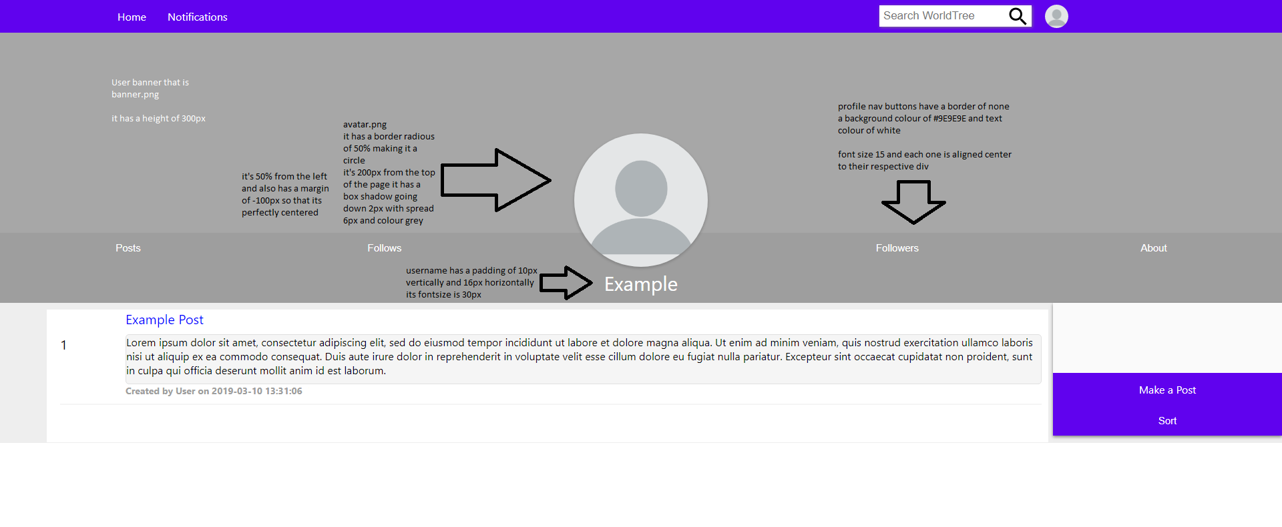

Should note that this is an example and that that is the reason why the creator of the post is user and not the username “Example”.

When hovering over a profilenav nav button their colour changes to #BDBDBD

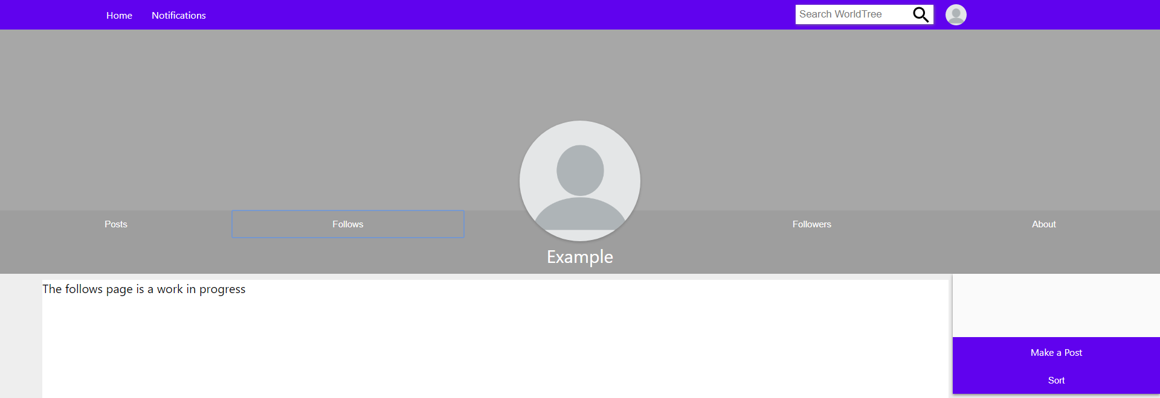

This is what the follows, followers and about areas of the profile page look like, with the font size of the text inside of the “Posts” div being 20px in size.

Search Page

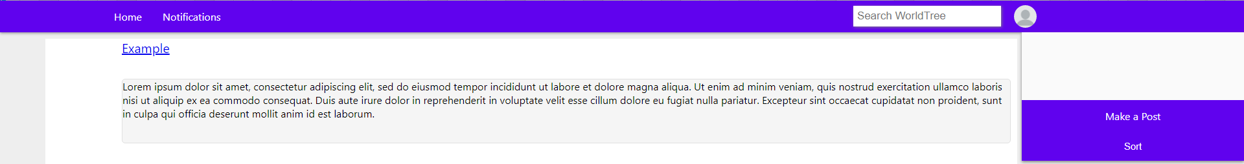

Only difference here is that the title of the “post” is a link. The user name is a link

The contents section has the same css

Settings Page

Case 1:

Preferences Page

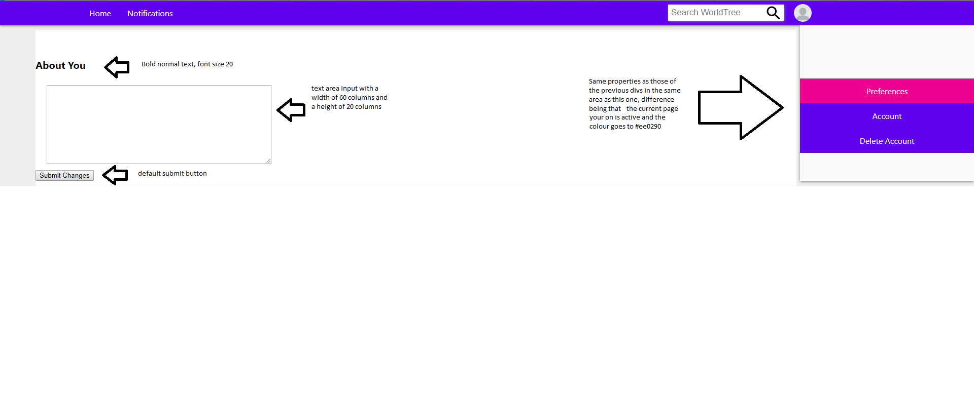

Case 2:

Account Page

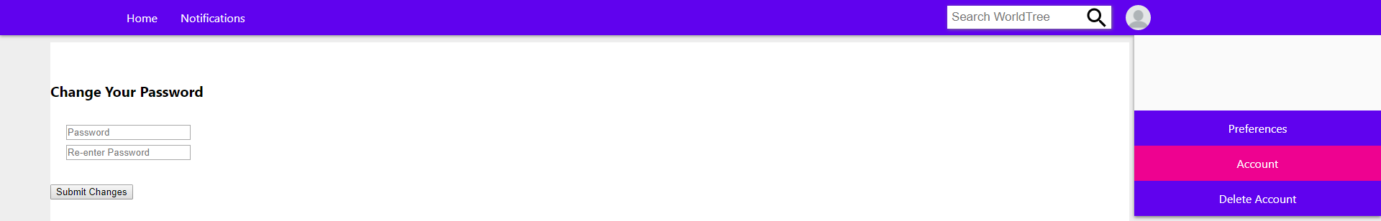

The password inputs are default inputs, everything else is the same

Case 3:

Delete Account Page

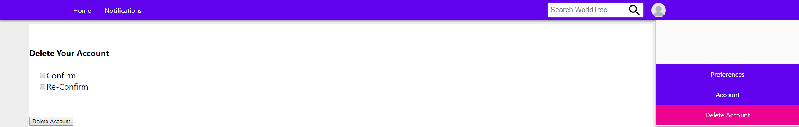

Only difference here is that the text next to the textboxes is not in bold. The form that is is the checkboxes have default css

Make a Post Page

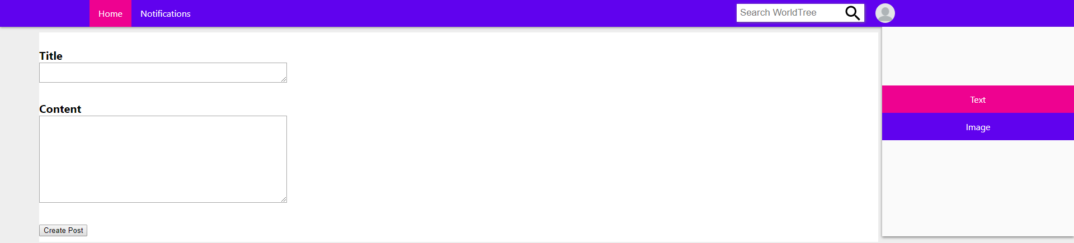

The text on this page is bold, the title and content text areas are default and the sidebar is like that of the previously shown settings page

Make an Image Post Page

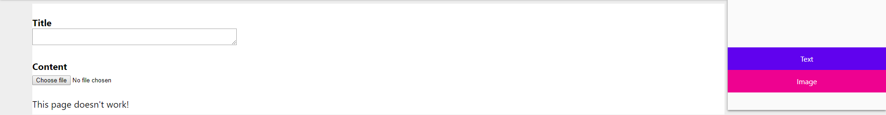

The form here, title, content, are default, their titles describing which each form inputs are in bold, the error message at the bottom has a text size of 20px